7 – 11 project demo:

Authentication and Authorization

Zuul Gateway and JWT Authentication

http request

Application launching steps:

Run

-> Eureka service

-> Zuul service

-> Employee service

-> User service.

Database setup:

Assuming ,

user name : root

Password: root

* Run the schema.sql file from the Sql folder and also run the data.sql on the mysql workbench to have the login users and employees data.

Authentication steps,

* For authentication <http://localhost:8095:/authenticate> username: admin password: pwd.
* This will return the token. Copy the token and paste it in every request header
* key :“Authorization” value: “Bearer {TOKEN returned from ‘/authenticate’ url}”

the above token and header need to added for every request Authorization.

Screenshot of the working application:

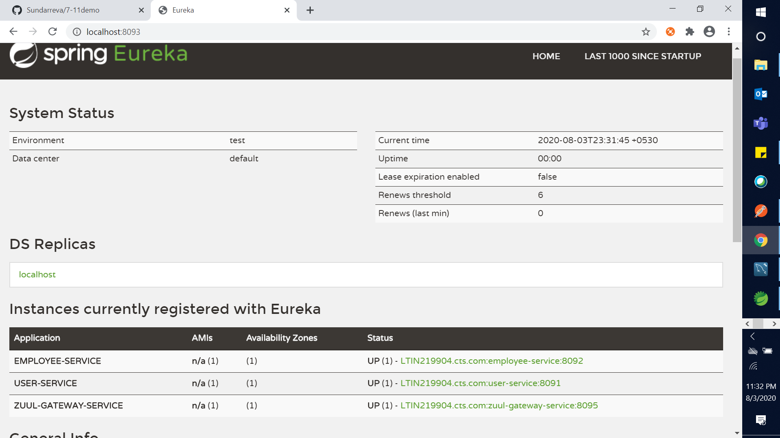

Eureka server registry

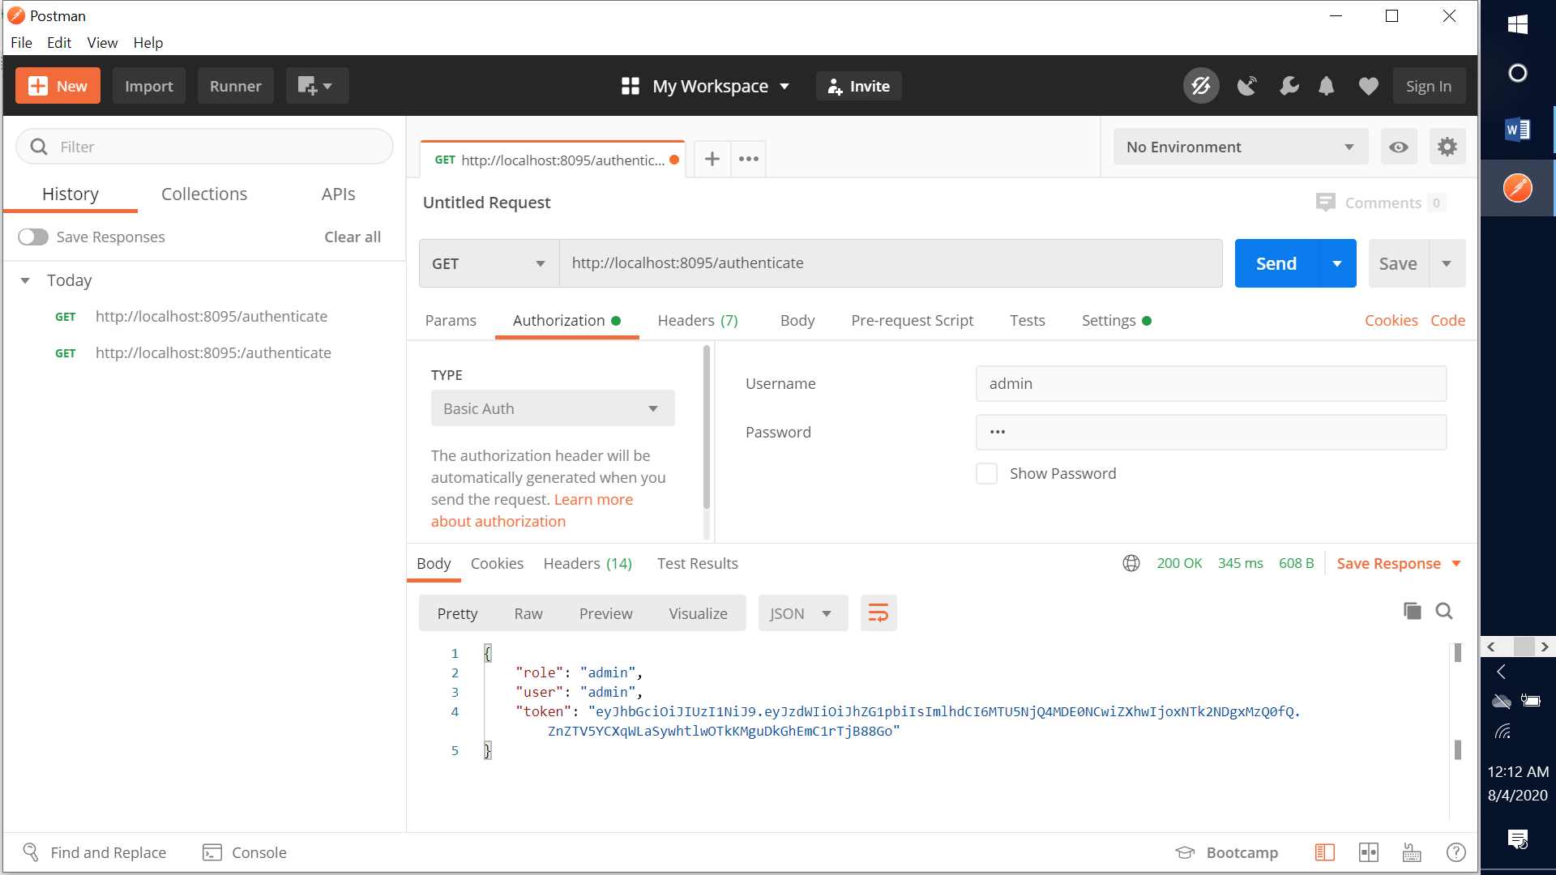

returns token for an valid user credentials

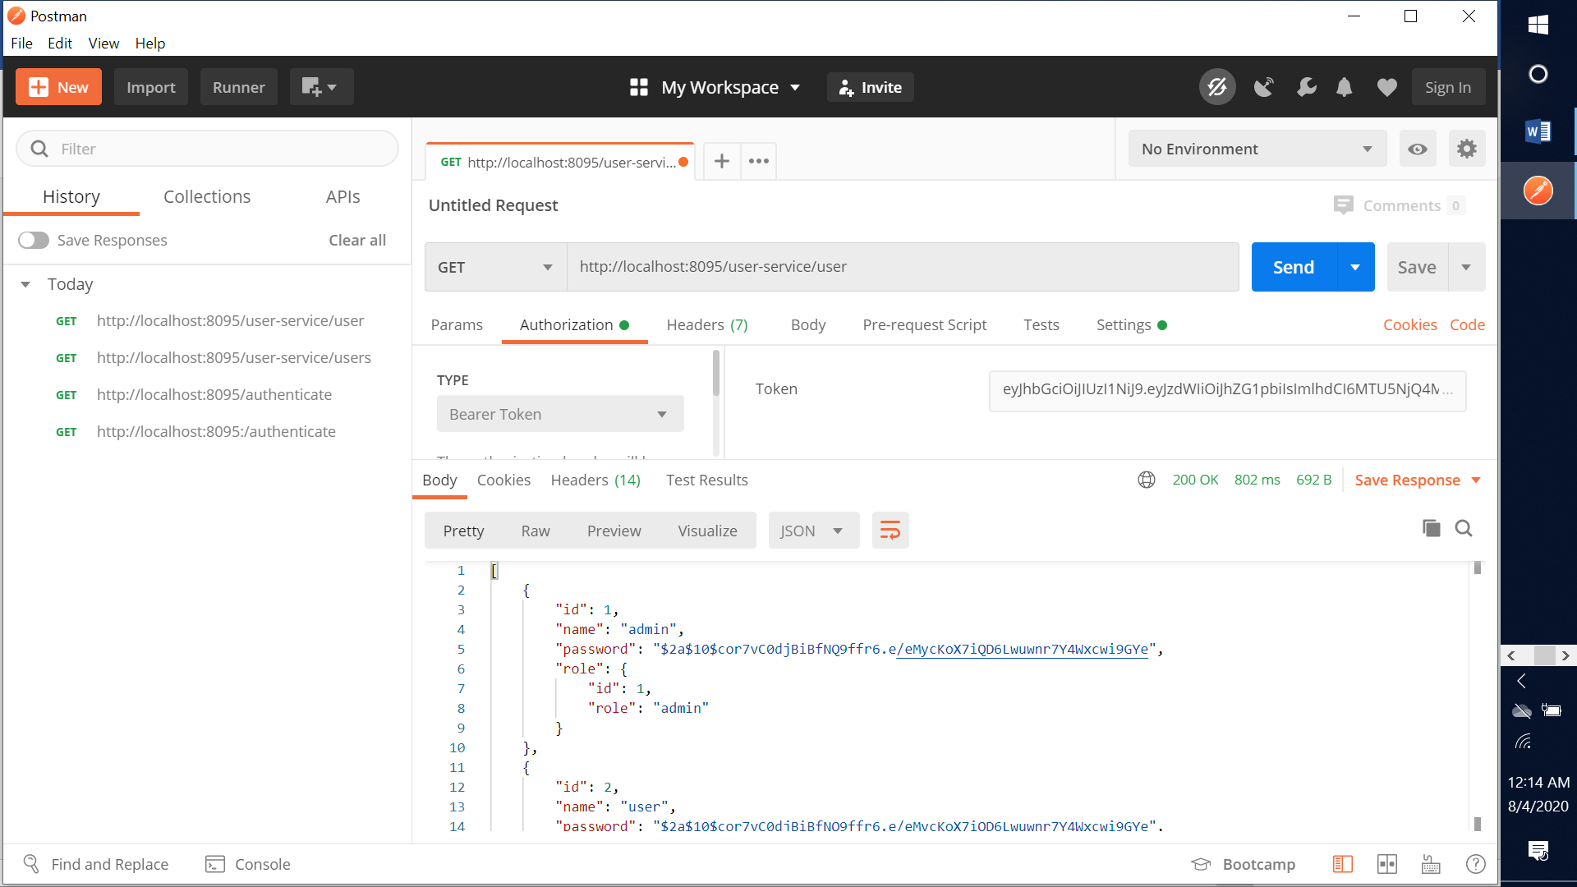

Retriving the user data from user service with JWT Token.

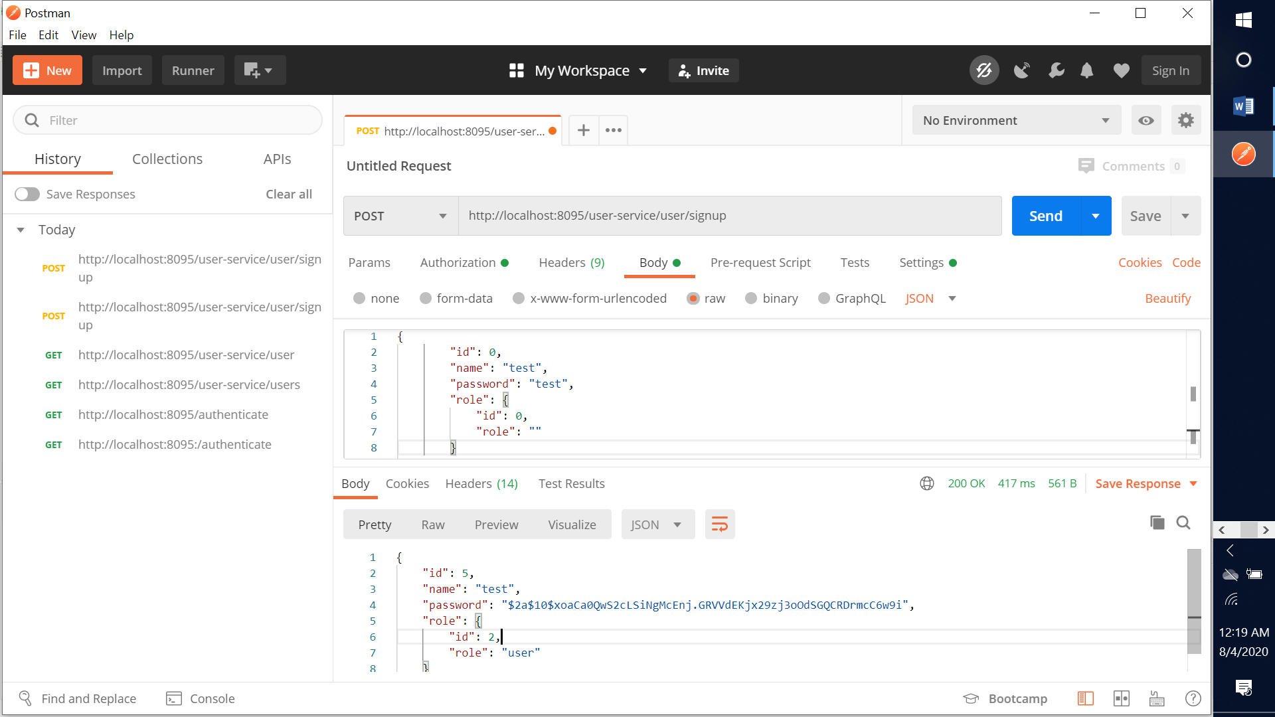

Post a user object for sign in.

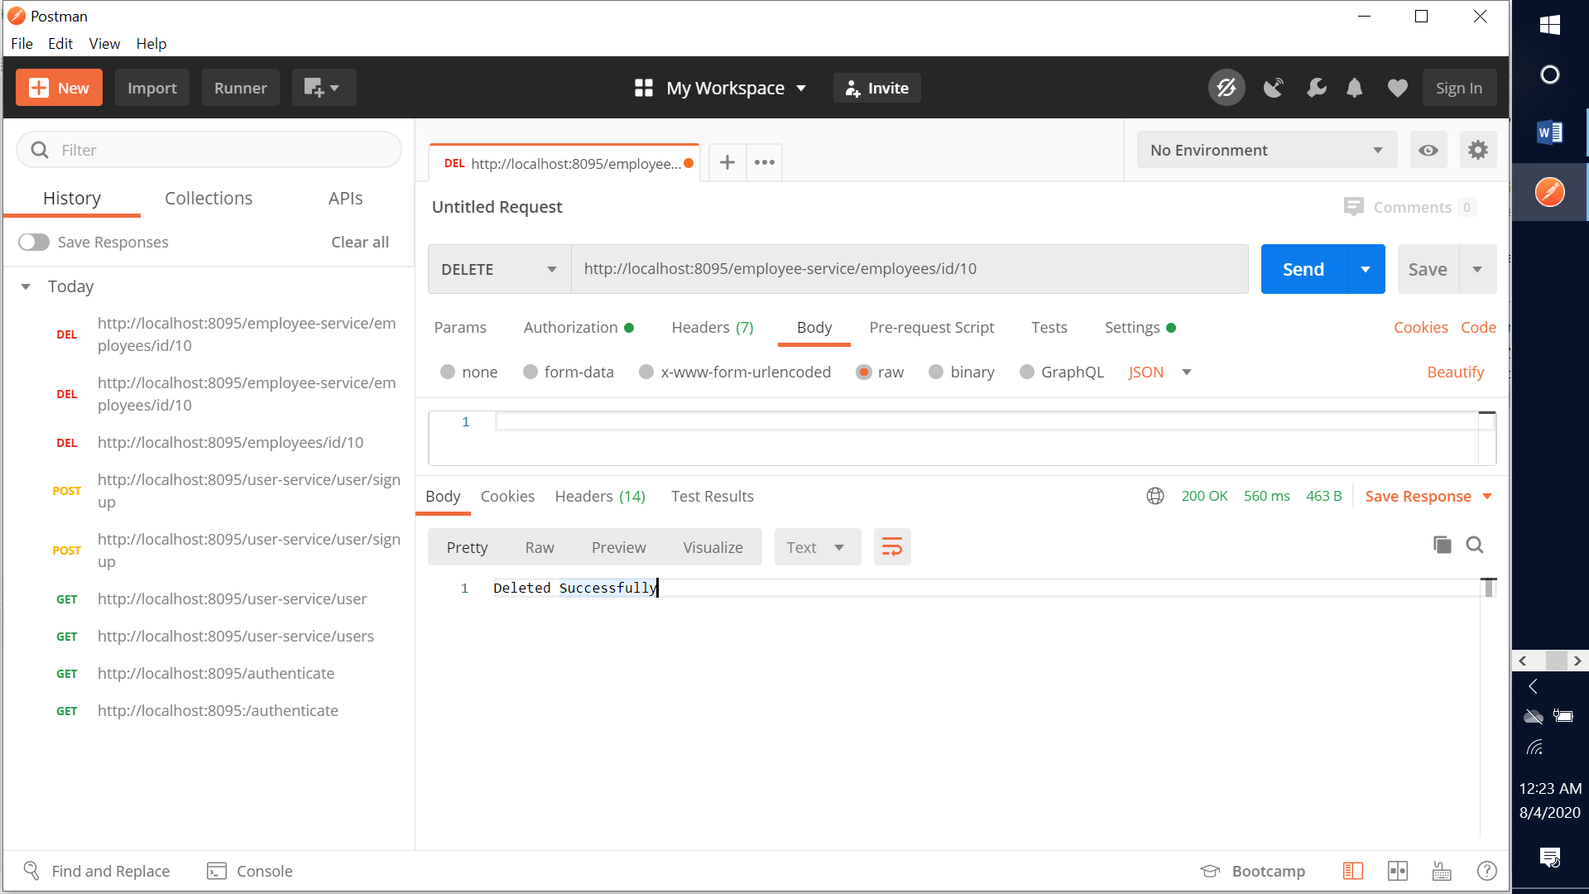

Delete an employee object by id -> employee id is 10.